Day -1

1. Input:

#age, frequency

age<-c(5,15,20,50,80,110)

frequency<-c(200,450,300,1500,700,44)

median(age)

median(frequency)

output:

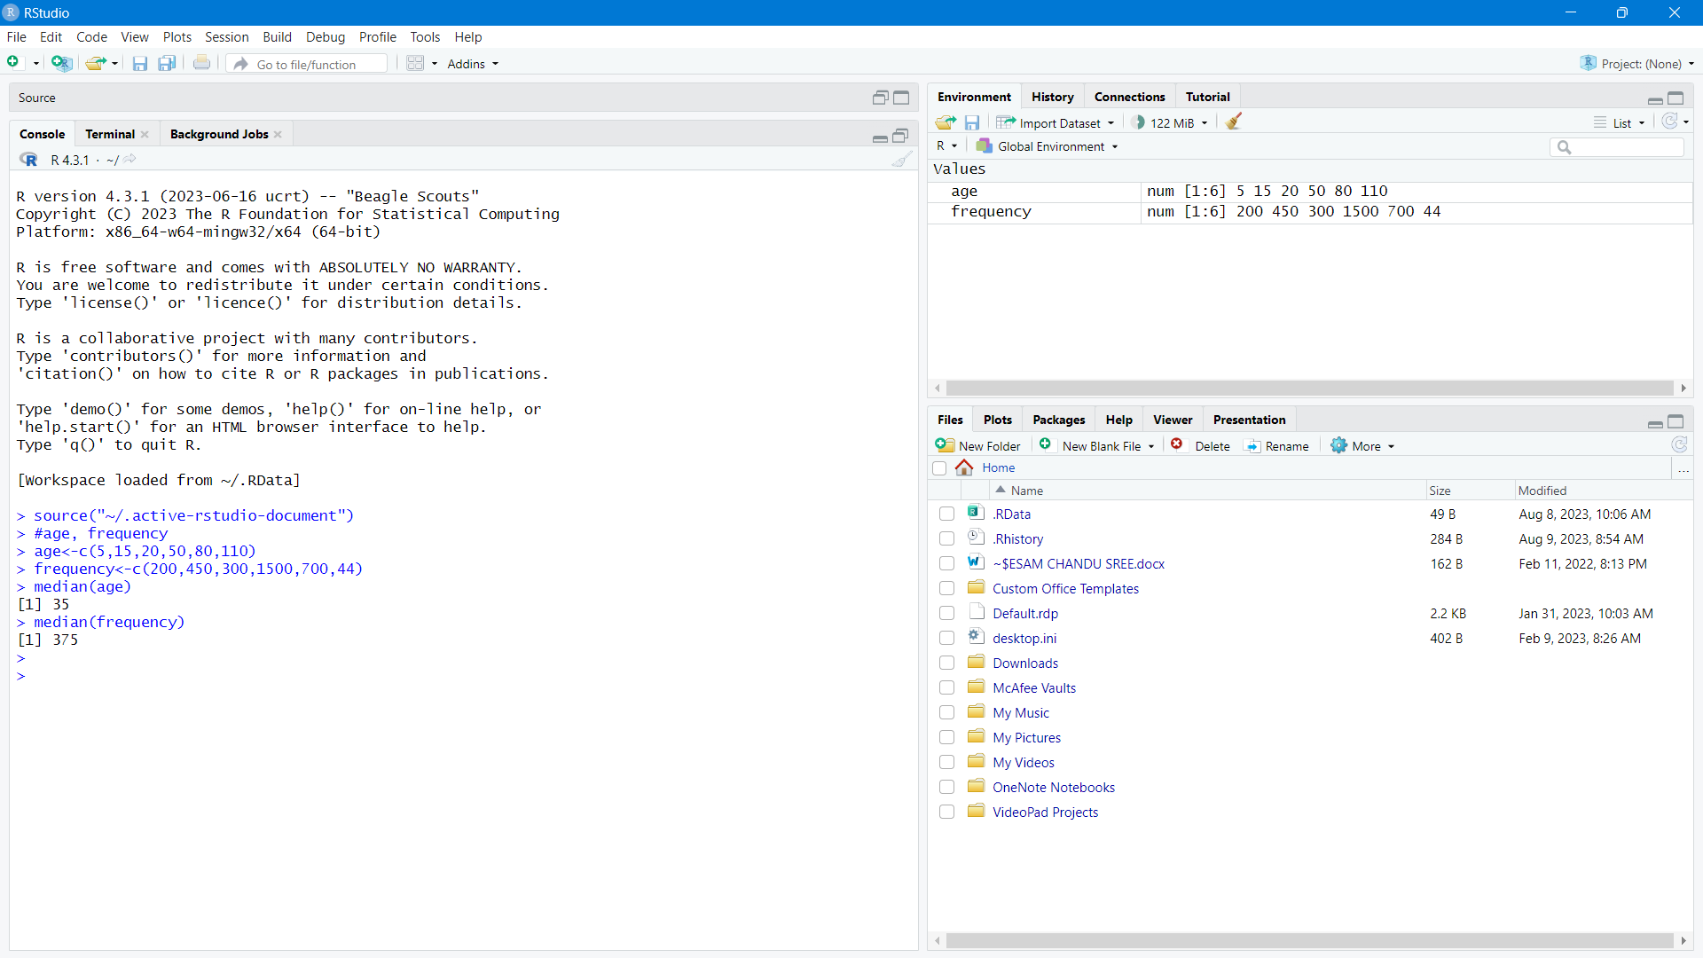

2. Input:

#mean,median,mode,quatile

age<-c(13,15,16,16,19,20,20,21,22,22,25,25,25,25,30,33,33,35,35,35,35,36,40,45,46,52,70)

mean(age)

median(age)

mode_age<-names(table(age))[table(age)==max(table(age))]

mode_age

range(age)

quantile(age,.25)

quantile(age,.75)

output:

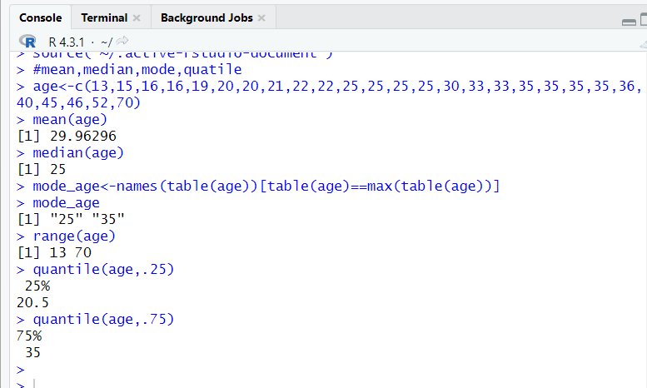

3. input:

data <- c(11,13,13,15,15,16,19,20,20,20,21,21,22,23,24,30,40,45,45,45,71,72,73,75)

bins <- 5

bin_indices <- cut(data, bins)

mean_smooth <- tapply(data, bin_indices, mean)

print(mean_smooth)

median_smooth <- tapply(data, bin_indices, median)

median_smooth

min_max_smooth <- tapply(data, bin_indices, function(x) c(min(x), max(x)))

print(min_max_smooth)

output:

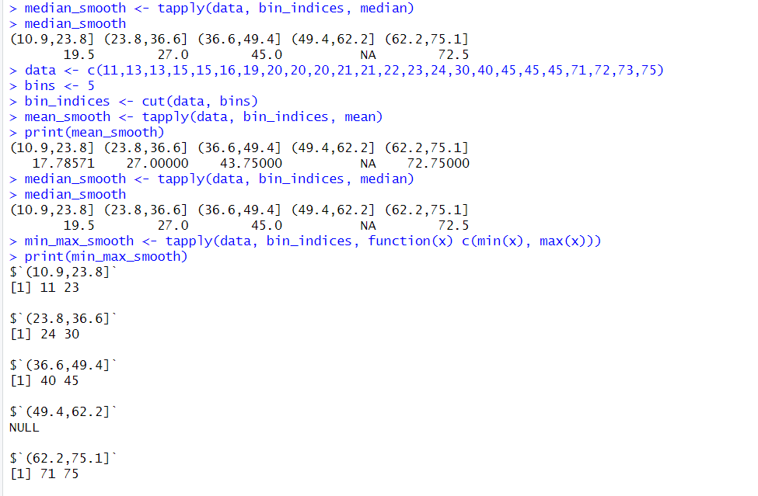

4. age<-c(23,23,27,27,39,41,47,49,50,52,54,54,56,57,58,58,60,61)

fat<-c(9.5,26.5,7.8,17.8,31.4,25.9,27.4,27.2,31.2,34.6,42.5,28.8,33.4,30.2,34.1,32.9,41.2,35.7)

mean(age)

median(age)

sd(age)

mean(fat)

median(fat)

sd(fat)

#boxplot

boxplot(age,fat)

#scatter plot

scatter.smooth(age,fat)

#qplot

qqplot(age,fat)

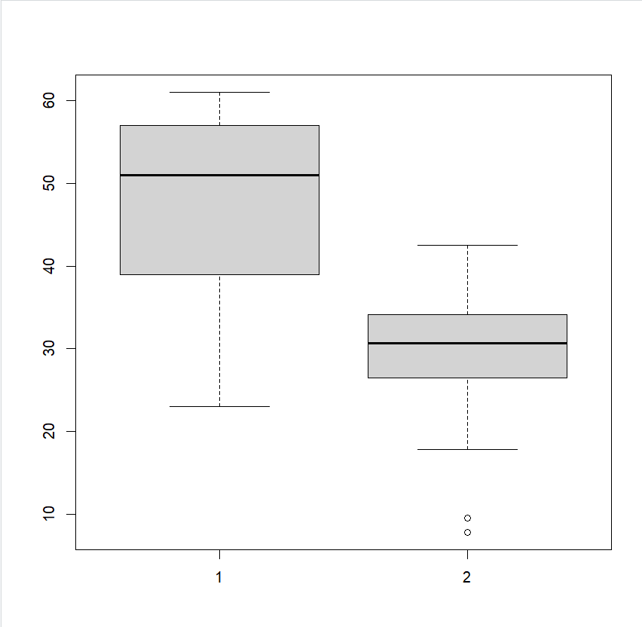output:

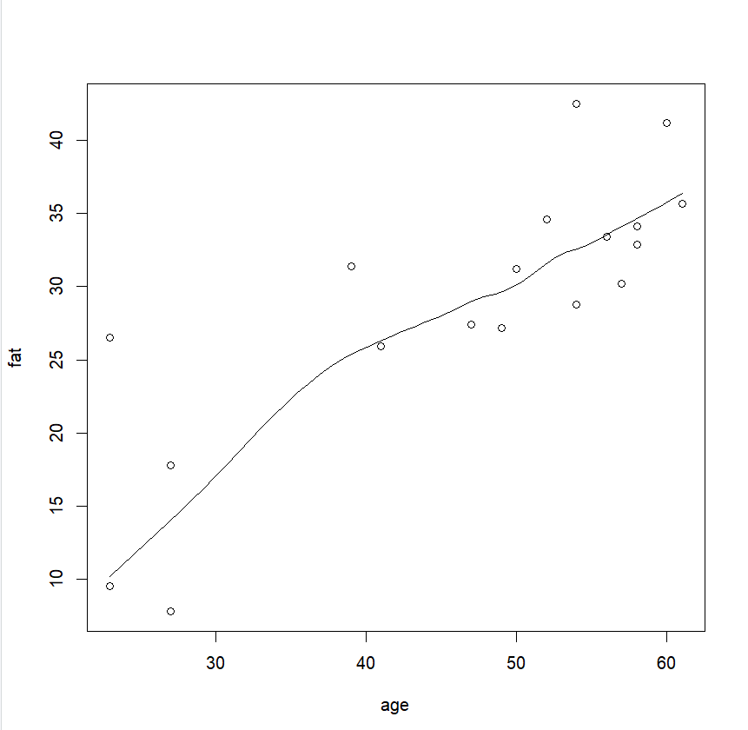

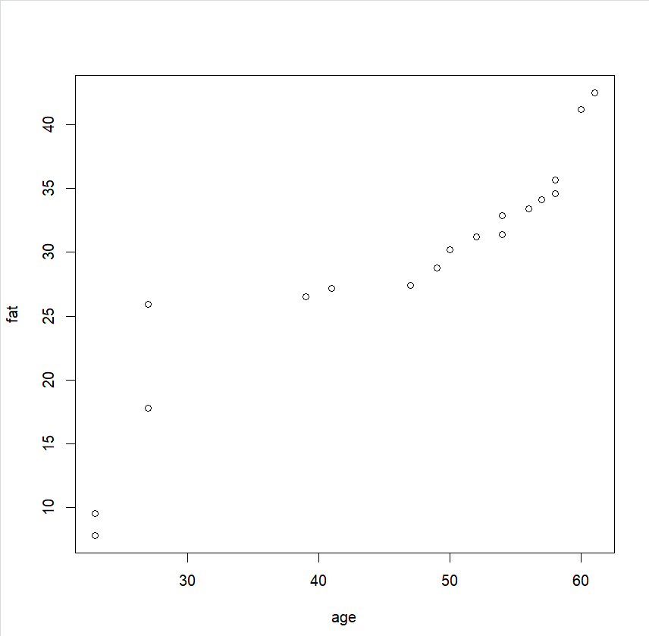

5. Input:

v<-c(23,23,27,27,39,41,47,49,50,52,54,54,56,57,58,58,60,61)

min<-0

max<-1

#min_max

min_max=((35-min(v))/(max(v)-min(v)))

print(min_max)

#z-score

m=mean(v)

s<-12.94

z_score=(35-m)/s

print(z_score)

#decimal scaling

m<-35

j=max(m)<1

decimal_scaling=m/10^j

print(decimal_scaling)

output:

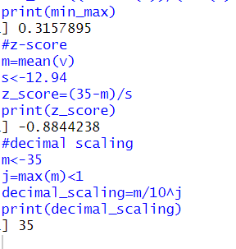

6. Input:

pencils<-c(9,25,23,12,11,6,7,8,9,10)

mean(pencils)

median(pencils)

mode=names(table(pencils))[table(pencils)==max(table(pencils))]

mode

output:

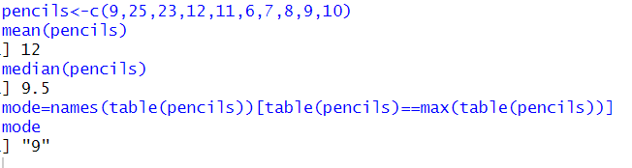

7. input:

#scatterplot

x<-c(4,1,5,7,10,2,50,25,90,36)

y<-c(12,5,13,19,31,7,153,72,275,110)

scatter.smooth(x,y)

output:

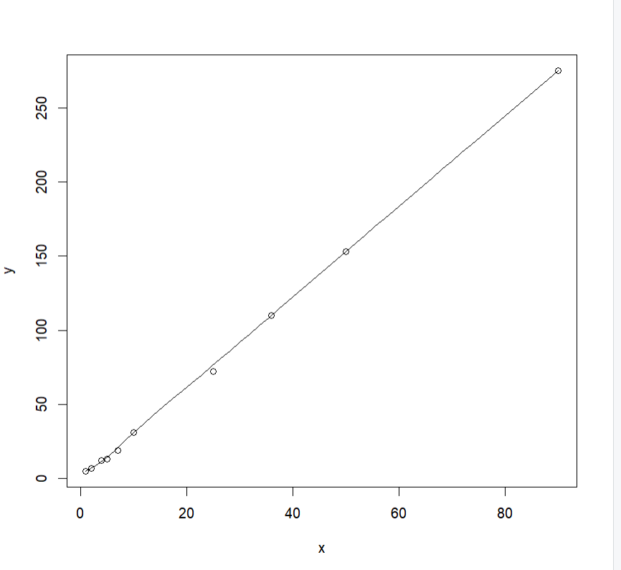

8. Input:

marks <- c(55, 60, 71, 63, 55, 65, 50, 55, 58, 59, 61, 63, 65, 67, 71, 72, 75)

num_bins <- 3

bins_eq_frequency <- cut(marks, breaks = num_bins, labels = FALSE)

hist(marks, breaks = num_bins, col = "lightblue", xlab = "Marks", main = "Equal-Frequency (Equi-Depth) Partitioning")

marks <- c(55, 60, 71, 63, 55, 65, 50, 55, 58, 59, 61, 63, 65, 67, 71, 72, 75)

bin_mean <- tapply(data, cut(data, num_bins), mean)

smoothed_data_by_mean <- unname(bin_mean[as.character(cut(data, num_bins))])

bin_median <- tapply(data, cut(data, num_bins), median)

smoothed_data_by_median <- unname(bin_median[as.character(cut(data, num_bins))])

bin_boundaries <- tapply(data, cut(data, num_bins), function(x) c(min(x), max(x)))

smoothed_data_by_boundaries <- unlist(bin_boundaries[as.character(cut(data, num_bins))])

print("Original data:")

print(data)

print("Smoothed data by bin mean:")

print(smoothed_data_by_mean)

print("Smoothed data by bin median:")

print(smoothed_data_by_median)

print("Smoothed data by bin boundaries:")

print(smoothed_data_by_boundaries)

output:

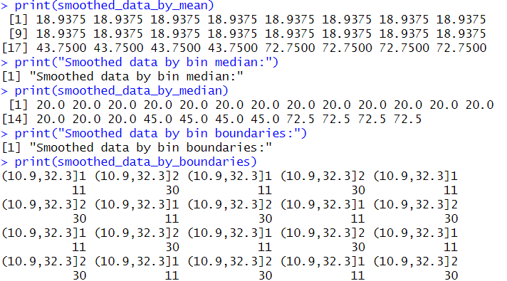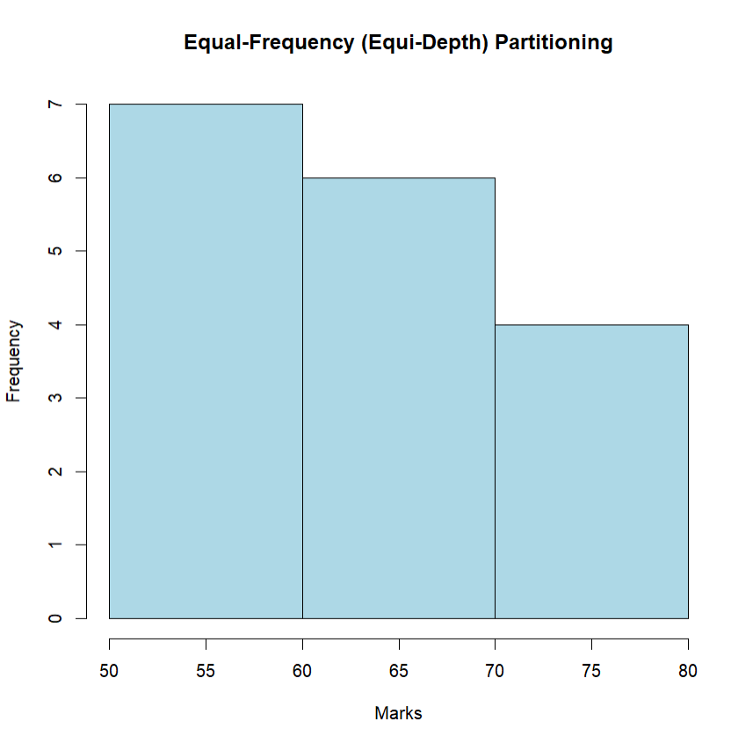

9. Input:

#IQR, SD

v<-c(78.3,81.8,82,74.2,83.4,84.5,82.9,77.5,80.9,70.6)

IQR(v)

sd(v)

output:

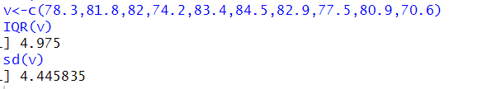

10. Input:

#Q1, Q2

age<-c(13,15,16,16,19,20,20,21,22,22,25,25,25,25,30,33,33,35,35,35,35,36,40,45,46,52,70)

quantile(age,.25)

quantile(age,.75)

output:

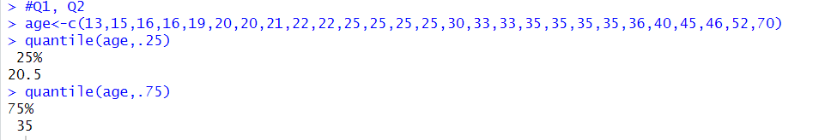

11. Input:

v<-c(200,300,400,500,600,1000)

min<-0

max<-1

for(i in v){

min_max=((i-200)/(1000-200))

print(min_max)

}

m=mean(v)

s=sd(v)

for(i in v){

z_score=(i-m)/s

print(z_score)

}

output:

